**Tubular Fixed Ladder**

**CAD Design of the Ladder:**

I have made the ladder in three parts. The Ladder, the Bracket and the Safety_tubes.

**The Ladder:** It contains the 2''*2''*1/4'' tubes and 3''*1''*1/4'' tubes. I would have used “Structural member” to make the 3’’*1’’*1/4’’ tubes also, but the problem is that this particular size is not available in “Rectangular tube”. So, I have just extruded two rectangles. But 2’’*2’’*1/4’’ tube size is available. So, I have proceeded with the Structural member for that.

**The Bracket:** Completely made with sheet metal. The radius of curvature at the edge is a random value. I can also make it a completely 90-degree bend, but to have a more practical look, I choose the curve.

**Safety tubes:** Here also, I faced the same problem of not finding the exact size (1''*1''*1/4'' tubes) in “Structural member”🡪 “Square tubes”.

So, I have again made it using simple extrusions. I have also added end caps mechanically (using extrusions again).

**Final Assembly:** using “linear pattern” and “Mirror”, I have duplicated all the copies required.

* These are the references I have found on the Internet for calculations for weldment thickness for Aluminium.

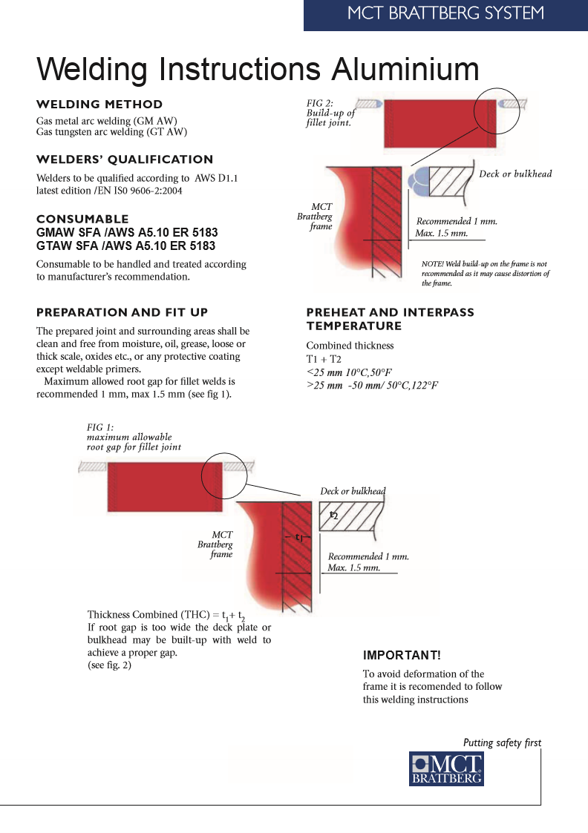

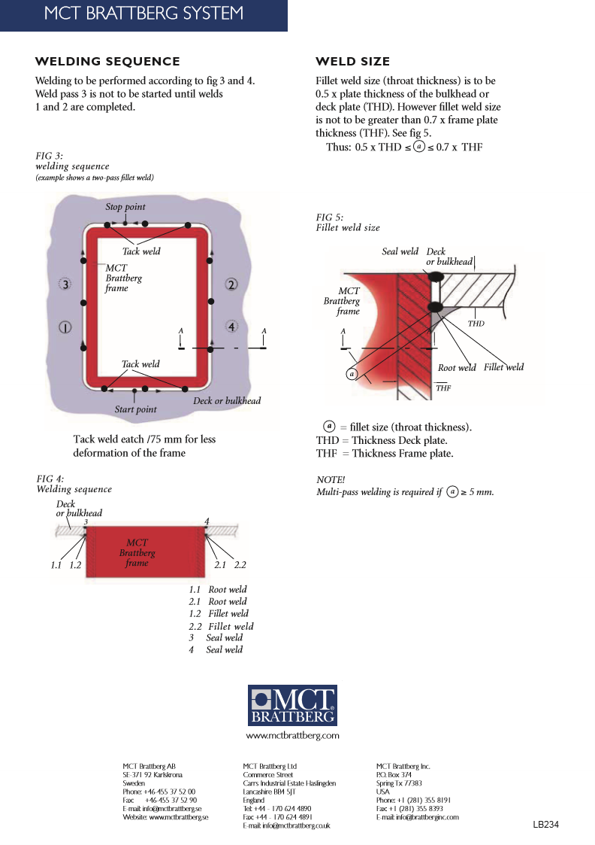

* [How do you determine the minimum size of a fillet weld? - TWI](https://www.twi-global.com/technical-knowledge/faqs/faq-how-do-you-determine-the-minimum-size-of-a-fillet-weld)
* There are four welds in the structure, i.e.,

1. between the brackets and 3''*1''*1/8'' tubes
2. Between 2''*2''*1/4'' tubes and 3''*1''*1/4'' tubes
3. Between 3''*1''*1/4'' tubes and 1''*1''*1/4'' tubes
4. Between 1''*1''*1/4'' tubes and 1''*1''*1/4'' tubes

* Though all the welds are fillet welds, the third type doesn't suit the type of weld that the above-mentioned file refers to. Also, the strength of first and second welds are much more important than the third. So, I have calculated the weld leg length only for first and second and have taken the same(0.2121 in) for third weld also.
* 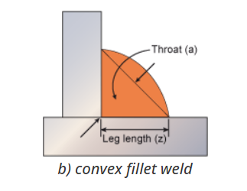
* For first weld, the data in the link above applies. As the thickness of bracket is 1/4 inch, the weld leg length can be taken as 1/8 inch.
* For the second weld, both THD and THF are 1/4 inch. So, throat thickness(t) should be in between 0.5*(1/4) and 0.7*(1/4). I went for the average value 0.6*1/4 = 0.15

Leg length = radius of the fillet = (2^0.5) *throat = 0.15*1.414 = 0.2121 inch.

* For the third weld, leg length = 0.2121 inch.
* For the Fourth type, I have not used any weld because I did not make it using a "structural member".

**About myself:** My name is Deepak, and I am from Vizag, Andhra Pradesh. I have just completed my 3rd Year in mechanical Engineering at IIT Ropar (Punjab).